IR-Optogenetic LED Panel

Vault Folder: Fly Bowl LEDs

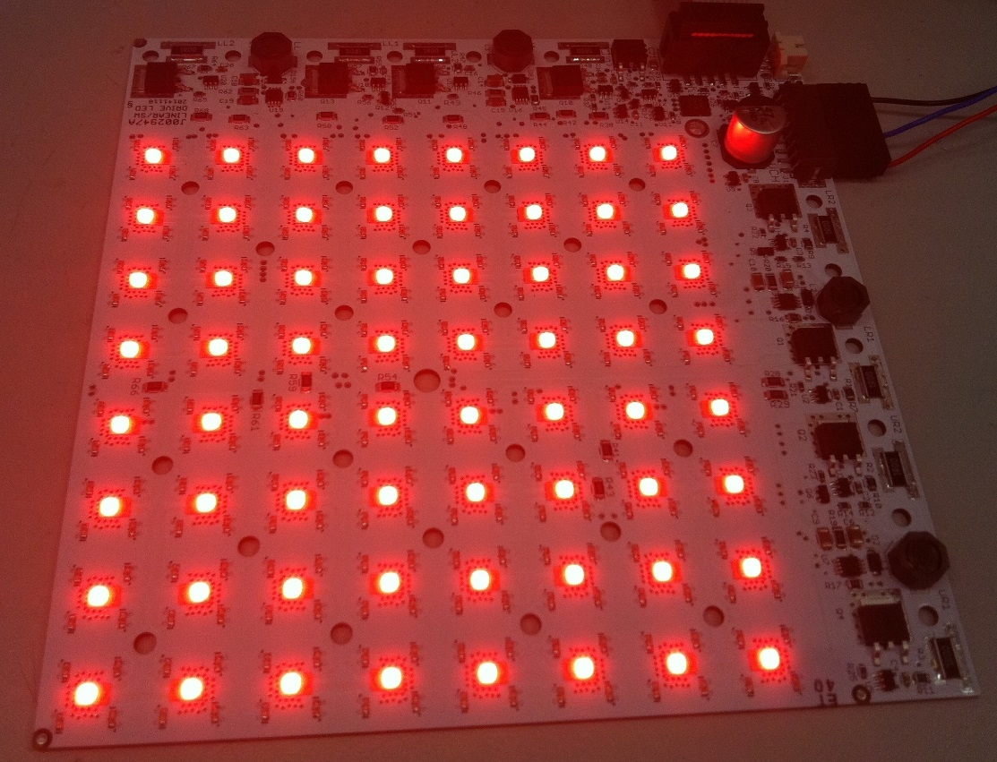

Steve Sawtelle  
Lead Electrical Engineer, ID&F  
(571) 209-4158

Contents

System Overview 2

Connectors 4

Control 4

# System Overview

The IR-Optogenetic LED Panel provides IR (infrared) backlight and optogenetic illumination. The typical application is backlighting for larva or flies, though it can used in other types of experimental setups. The illuminated area is about 114 x 114 mm (4.5 x 4.5 inches). The optogenetic lighting is broken up into four quadrants to allow targeted optogenetic activation. Four panels can be set up in a square to provide a 228 mm x 228 mm (9 x 9 inches) backlight, resulting in 16 areas with independent on/off control.

The IR lighting (850nm) is controlled by a single 0-2.5V analog signal (voltage below 0.2V is off). The optogenetic lighting has a single intensity control provided by a 0-2.5V analog signal. Four on/off controls provide the means to turn each optogenetic lighting quadrant on and off. The control signals can be manual (a 5V source is provided to drive external potentiometer/voltage dividers and switches), via a NI-DAQ (or similar digital/analog I/O board), or via the HHMI/Janelia IR/Optogenetic Panel Controller.

A marker signal is available and is typically used to light a separate IR LED in sync with any optogenetic on/off control being on. This allows a camera with a high pass filter to record when optogenetic stimulation is occurring. The marker signal is a logic OR of the 4 on/off signals and the marker input signal. If the marker signal is on when one of the on/off signals is active, the marker LED intensity will increase, which may be useful in certain protocols.

The board should be mounted on a heat sink using 3mm or #4 screws. Plastic washers or screws must be used to prevent shorting tracks on the top of the printed circuit board. A non-electrically conductive thermal pad (such as t-Global H48-6G-300-300-0.3) should be used between the board and the heat sink. The heat sink requirements vary depending on the LED intensities used and the duty cycle. For low light, a piece of aluminum plate may be sufficient, higher intensities may require a finned heat sink or cold plate. Adapter plates can be made to attach the panel to a standard optical breadboard or cold plate.

A 6.3mm (1/4”) hole is placed in the center of the lighted area to allow for plumbing or wiring to extend up through the board.

A minimum component-free space of 2.5mm (0.1”) is provided between quadrants to allow for vertical light barriers to be added to the top of the panel.

A diffuser is required to create uniform lighting. A diffuser can be made from 3mm (1/8”) white acrylic placed 12mm (1/2”) or more above the panel.

Power for the board is supplied by two separate supplies (one for IR and the other for optogenetic and control). The default setup, at maximum intensity, requires an IR supply of 36VDC at 0.8A, and an optogenetic supply of 24VDC at 3.2A.

Hardware Development

Different optogenetic experiments require different light intensities to achieve proper activation. This depends on the subject (fly/larva), targeted area, and activation type. The board was designed to maximize the flexibility in setting intensity, while minimizing heating. Although PWM (pulse width modulation) is the highest efficiency control, it is limited in range and may be problematic if the experiment’s on/off control is pulsed at a high rate. Since the optogenetic lighting is usually intermittent, it was decided to use linear intensity control to provide the broadest range in intensity and remove any question of PWM effects on the experiment. On the other hand, the IR lighting is usually on full time and does not require as fine adjustment, so a PWM driver is used here. This is also out of the visible wavelength range for a fly.

Current sense resistors are used in both lighting controls to set maximum intensity. These can be changed to provide lower ranges (useful in larva experiments). The optogenetic lighting uses a constant current source with a sense resistor between the power FET source and ground. The maximum current is set by Imax = 0.4V/R. The board is designed with a 1 ohm sense resistor, which yields 0-400mA of current control. Higher value resistors can be used to change the range, i.e.: a 5 ohm resistor would allow a maximum of 80 mA. A lower value resistor could be used to get higher current, but most of the Rebel Luxeon LEDs (used on this board for optogenetic light) are limited to 350mA. The resistor is a size 2512 (reversed 1225). There are eight of these per board and their locations are obvious as they are the only large resistors on the board. The IR intensity control uses a PWM driver. The sense resistor for this circuit provides maximum current control equal to 0.2V/R. This current is shared between 4 strings of IR LEDs, so each LED current is equal to 0.05V/R. The default resistor is 1 ohm so maximum current per LED is 50mA. The IR LEDs handle up to 100mA, so a sense resistor as low as 0.5 ohms could be used, though the default setting works well for most camera setups. These sense resistors are size 1206 and there are four per board located just at the end of each driver chip (AP8802 in an SO-8 package).

Using two power supplies allows the use of inexpensive wall power supplies, and reduces heating by matching the supply to the loads. It also reduces crosstalk between the lighting, so that IR intensity is not very affected by possible high current pulsing of the optogenetic lighting.

*Schematic, Printed Circuit Board,* *Materials*

See addendum – IR/Optogenetic LED Panel.pdf

# Connectors

**J1** 2.1mm x 5.5m DC Power Barrel jack

Power input for optogenetic. 24V at 3.2A.

**J1** 2.5mm x 5.5m DC Power Barrel jack

Power input for IR. 36V at 0.8.

**J3** – 2 pin, 2mm header (Hirose DF3DZ-2P-2H(51)); Mates with Receptacle DF3-2S-2C and terminals DF3-2428SCFC. Pre-terminated wires available from Digi-Key.

Connection for external marker LED. Pin 1 attaches to the LED cathode, pin2 to the anode.

**JP1**– 2x5 ribbon cable header

This header is used for control signal for the panel:

**Pinout**

|  |  |
| --- | --- |
| Pin | Function |
| 1 | Optogenetic lower left on/off (TTL high is on) |
| 2 | Optogenetic upper left on/off (TTL high is on) |
| 3 | Optogenetic lower right on/off (TTL high is on) |
| 4 | Optogenetic upper right left on/off (TTL high is on) |
| 5 | Ground |
| 6 | Marker signal (low turns on marker) |
| 7 | +5V out (low current) |
| 8 | Optogenetic brightness control (0-2.5V in analog) |
| 9 | IR brightness control (0-2.5V in analog) |
| 10 | Ground |

# Control

The panel can be controlled manually, via an I/O board (such as a NI-DAQ), or a dedicated controller (Janelia IR/Optogenetic Panel Controller).

Manual Operation

The on board 5V output can be used to make a manual controller:

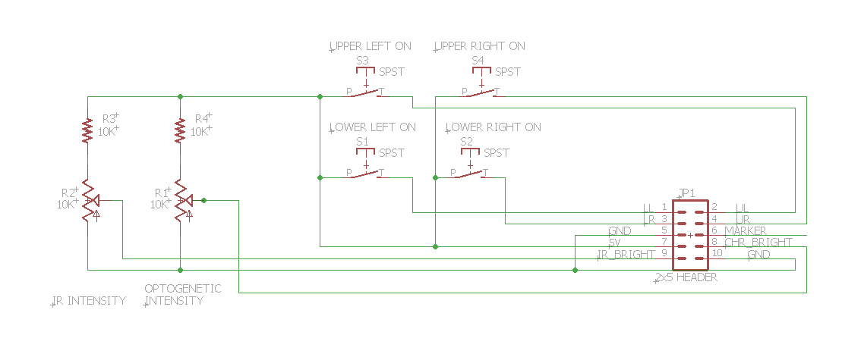

I/O Board Control

An I/O Board such as a NI-DAQ can be used to control the panel. A panel requires two 0-2.5V analog voltages to set intensity and 4 TTL compatible signals for optogenetic on/off control. The TTL signals are active high and must be able to source 5mA of current.

Dedicated Controller

The HHMI/Janelia IR/Optogenetic Panel Controller is designed to directly control up to four panels. A host computer can communicate with it via a USB/Serial connection. See the documentation for this device for details.